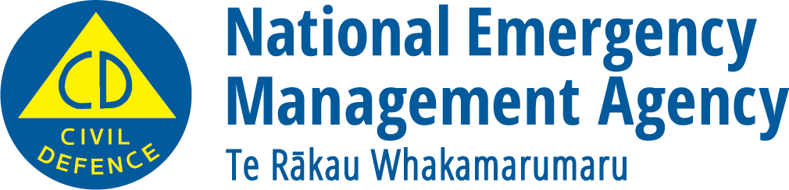
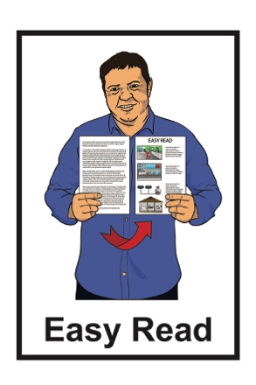

What you can do to be ready
for space weather
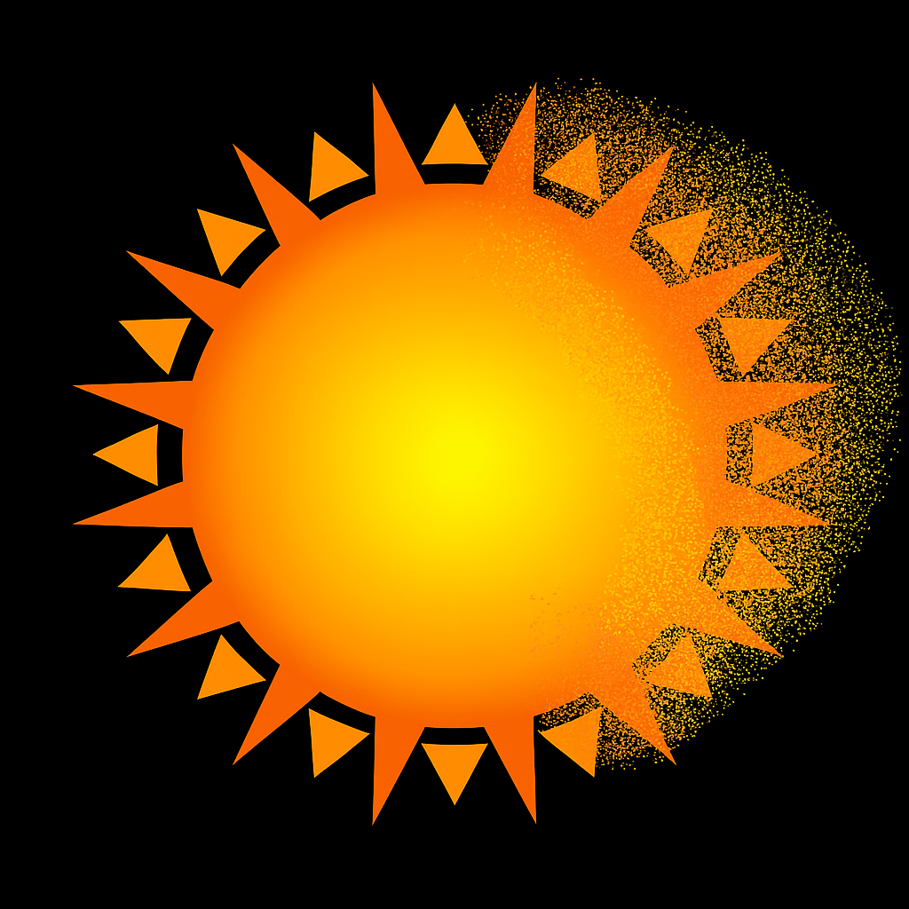

Published: July 2025

What you will find in here

Page number:

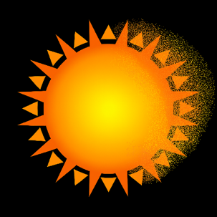
What is space weather? 2

What can happen during
space weather 5
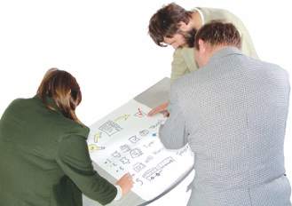

How to get ready for
space weather 8
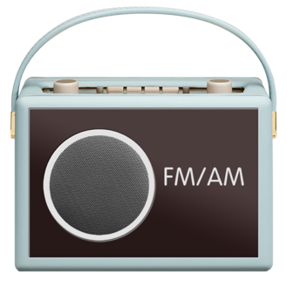

What to do when there is
space weather 12
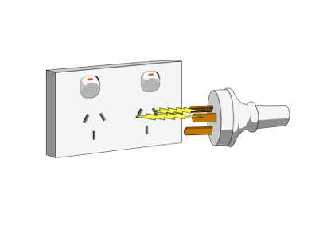

What to do after space weather 19

What is space weather?

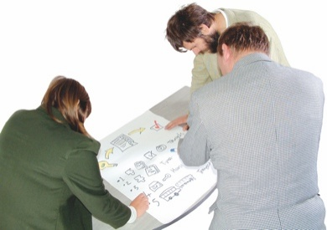
This Easy Read document has information about how to get ready for space weather.

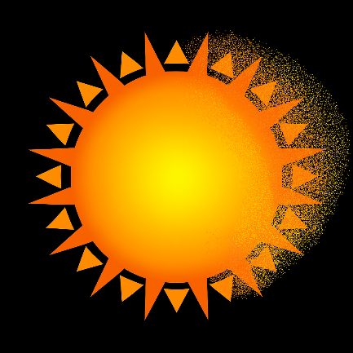
Space weather is when the sun gives out a lot of energy all at once.

Space weather is sometimes called a solar storm.

What happens during space weather / solar storm:
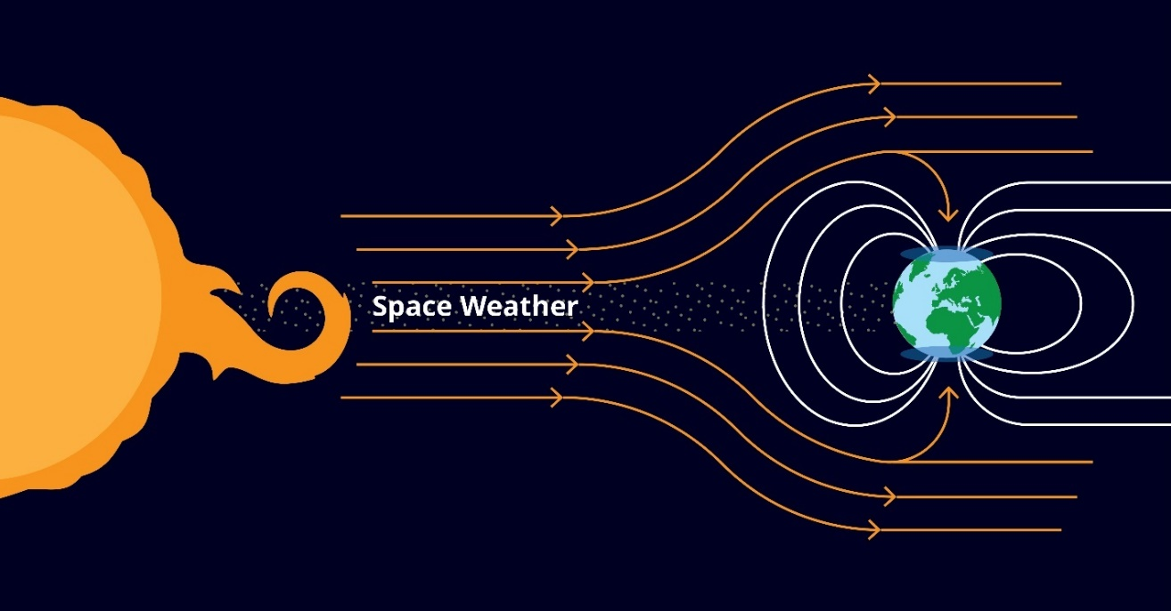
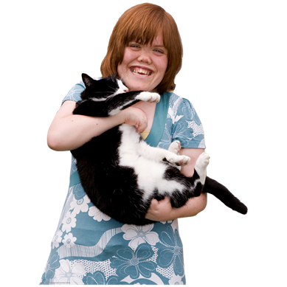
Space weather will not hurt:
people
animals.

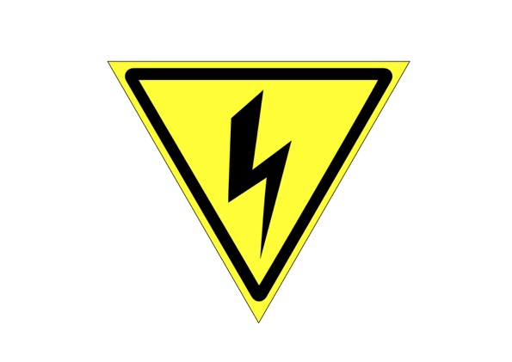
Space weather can damage the electricity network.

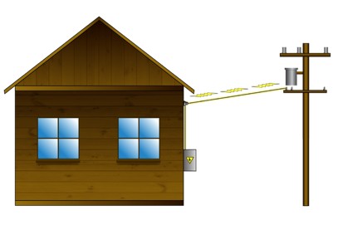
The electricity network is all the powerlines / cables that take electricity:
from where it is made
to the places it is used like houses.

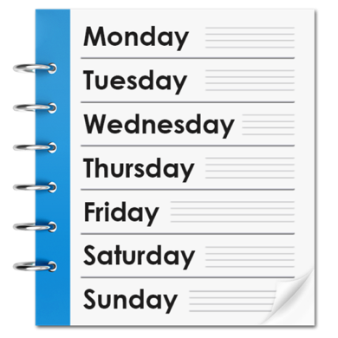
After a very big solar storm the electricity network could stop working for up to a week.

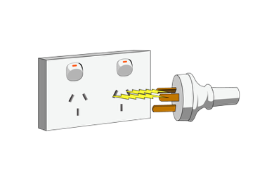

The electricity network not working is also called a power cut.
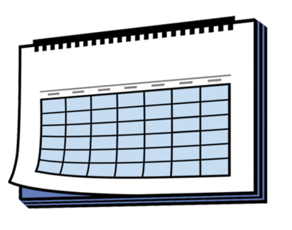

Very bad space weather does not happen often.

What can happen during space weather

Space weather can damage the electricity network.


If space weather is coming Transpower may turn off the electricity network.

Transpower is the organisation that:
owns the electricity network in Aotearoa New Zealand
makes sure the electricity network keeps working well.
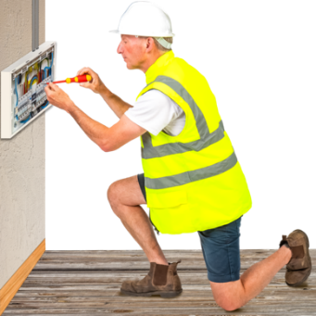

Turning off the electricity network stops it getting damaged in ways that will take a long time to fix.
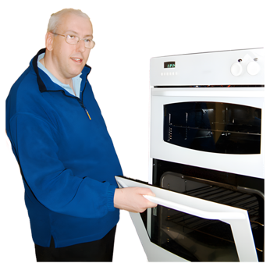
Having no electricity makes it hard to do things like:
cook
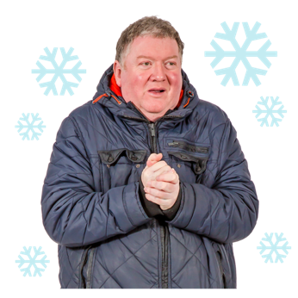
wash things like dishes
have a shower / bath
keep warm.

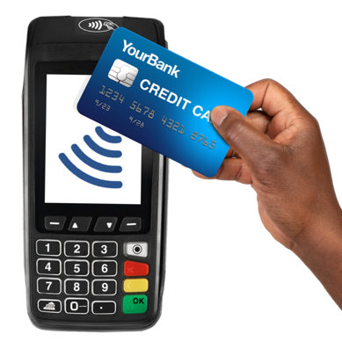
Having no electricity may also cause problems with things like:
using EFTPOS / a card to pay for things
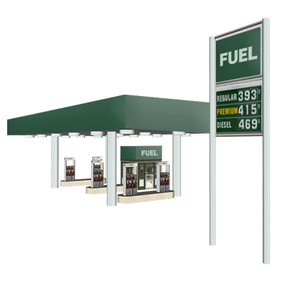
putting petrol in your car at a service station
supermarkets having enough food / supplies.

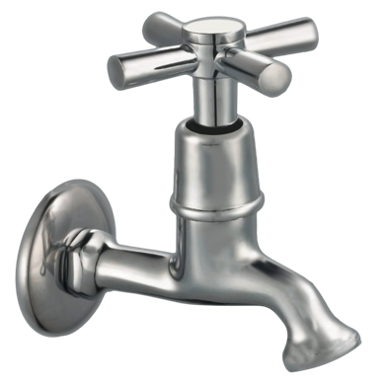
Having no electricity can also cause problems with things like:
having water in your taps
sewerage.
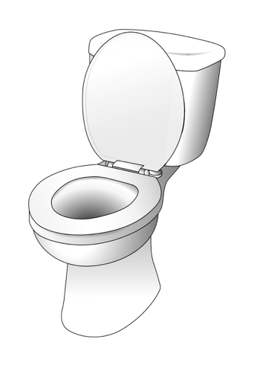

Sewerage means the pipes that take away wastewater like when you flush the toilet.

How to get ready for space weather

You can make a household plan so everyone in your house knows what to do when there is space weather.

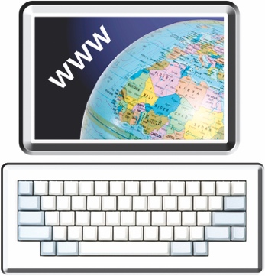
There is Easy Read information about making a household plan on the Get Ready website:

https://tinyurl.com/yw4j5ahr

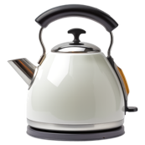
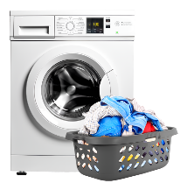
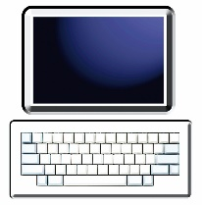
To make a plan for space weather think about all the things in your home that use electricity.


You may need to find out if there is anything that would not be safe in a power cut.

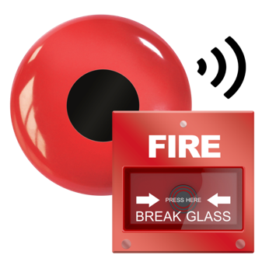
You may also need to find out if a power cut would stop you:
getting into your home
using alarms like fire alarms.
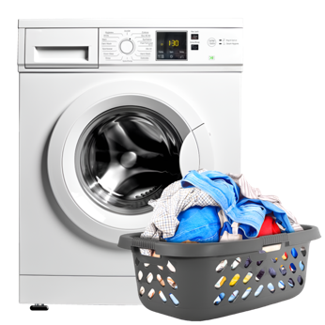

When the electricity comes back on it can damage things like:
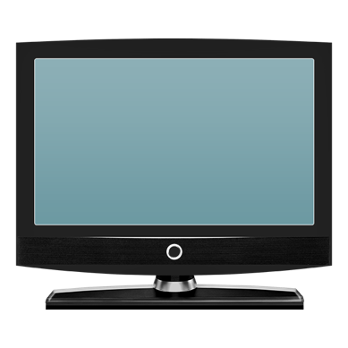
washing machines
computers
TVs.

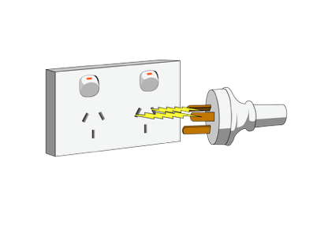
It is a good idea to unplug as many things as you can when there is a power cut.
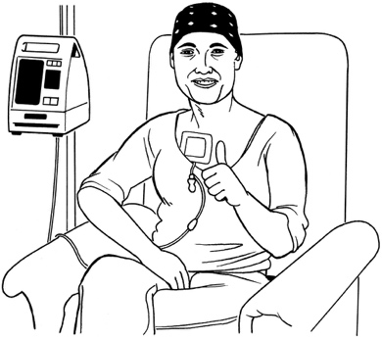
Some people are medically dependent on electricity.

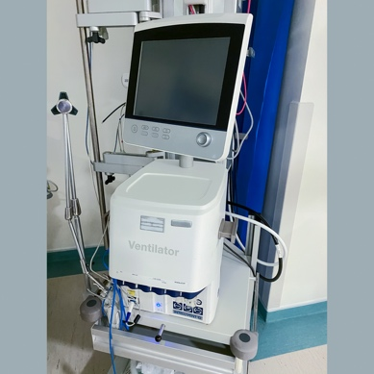
Medically dependent means you need electricity to run important medical equipment like:
oxygen if it is hard for you to breathe
a dialysis machine if you have kidney disease.

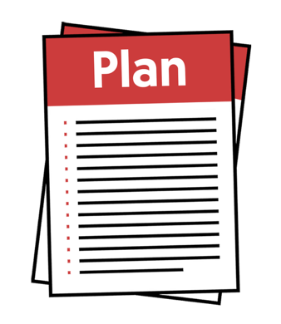
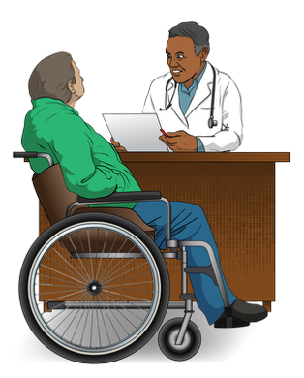
If you are medically dependent on electricity you can make a plan for when there is a power cut by talking to your:
electricity company
healthcare provider like your doctor.

There is information about getting ready for power cuts when you are medically dependent on electricity on the Electricity Authority website at:

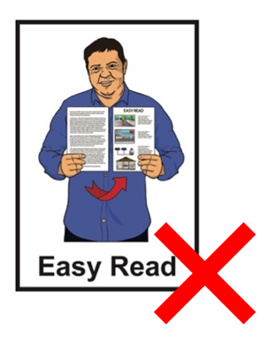
https://tinyurl.com/ms2fnbvj

This website is not in Easy Read.

What to do when there is space weather

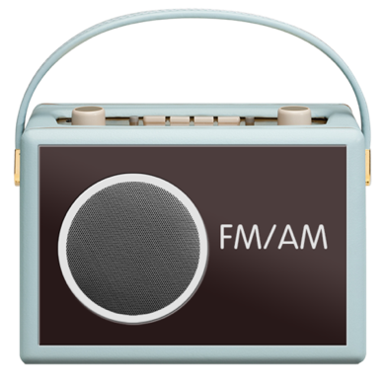
During space weather you can listen to the radio to get information from:
emergency services like the fire service
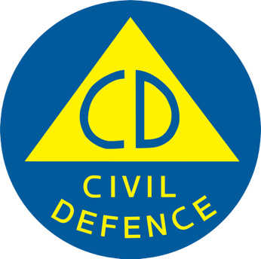
civil defence.

Civil defence supports people when there is an emergency.
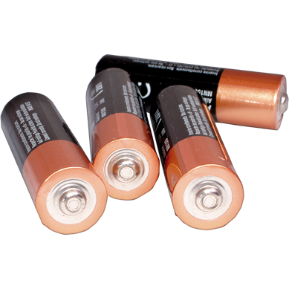

You can listen to the radio on a:
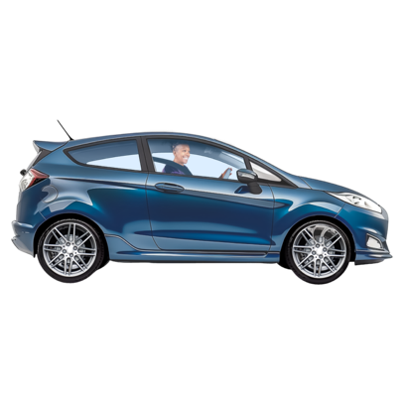
battery powered radio
solar / sun powered radio
car radio.

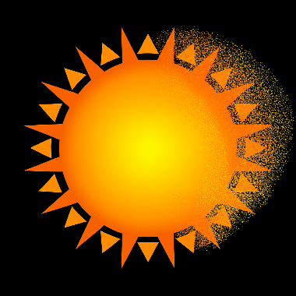
These radios will all work during:
space weather
a power cut.

Electricity that does not come from the electricity network is likely to work during space weather.

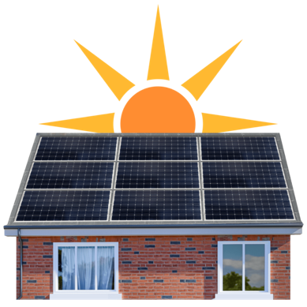
You will probably be able to use electricity that comes from:
solar panels
generators.

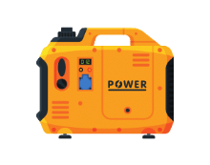
Generators are machines that make energy.

Generators use fuel like diesel.
There is information about how to use a generator safely on the WorkSafe website at:

https://tinyurl.com/3ay9pdxb

This website is not in Easy Read.

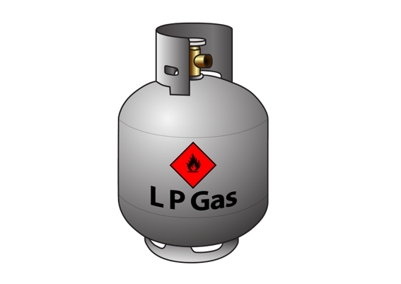
You can use things that run off gas like:
barbecues
heaters.
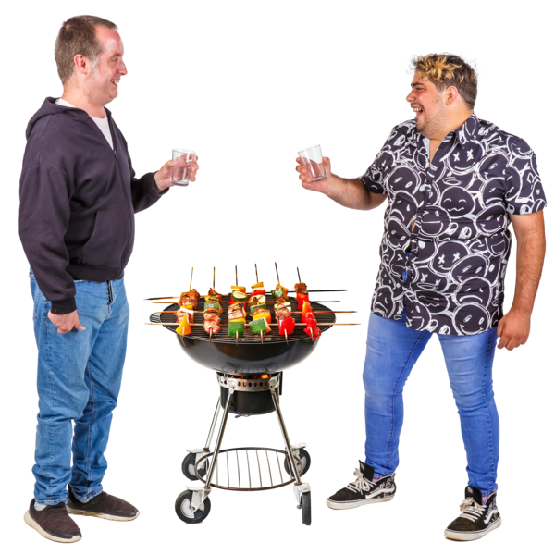

It is dangerous to use outdoor appliances like barbecues indoors.

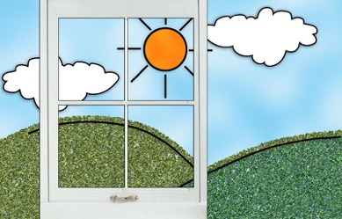
You should only use barbecues outdoors.

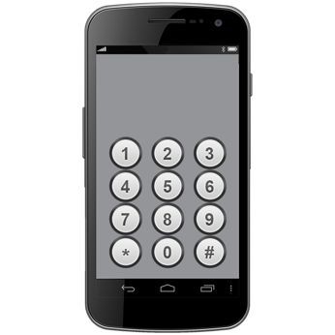
Your mobile phone might not work at the start of space weather.

Mobile phones will work again:
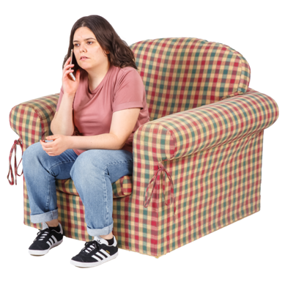
after a little while
before the electricity comes back on.

You can use your car to charge your mobile phone.

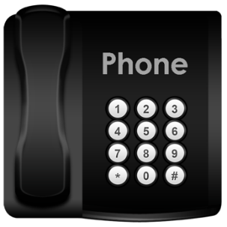
Landline phones will not work when there is a power cut.


Food that is in your fridge / freezer may go off if it gets too warm.

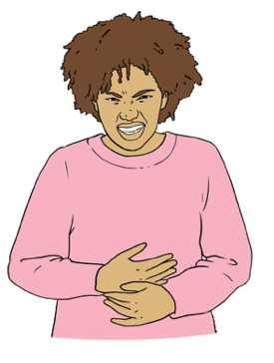
Food that has gone off can make you very sick.

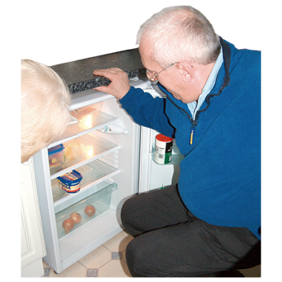
If there is a power cut eat the food that is in your fridge first.

Next eat the food from your freezer.

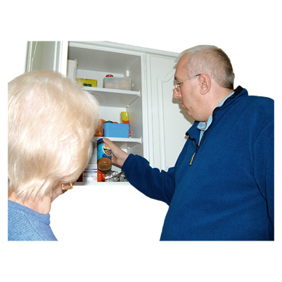
Last eat the food from your:
cupboard / pantry
emergency kit.
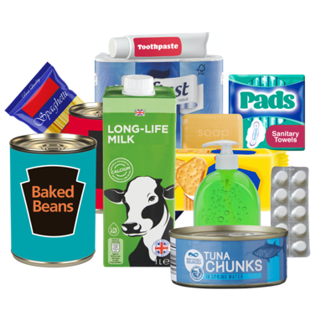

An emergency kit is all the things you need to get by in an emergency.

There is Easy Read information about the things you may need in an emergency kit on the Get Ready website at:

https://tinyurl.com/2ueftknv


Do not eat any food that:
smells bad / funny
looks different from usual.
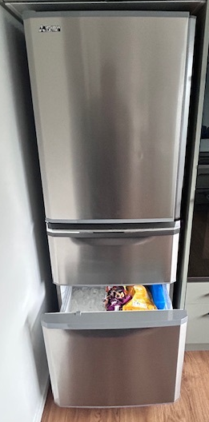

If food in your freezer has
defrosted / thawed all the way it is not safe to freeze it again.

There is information about keeping food safe on this website:

https://tinyurl.com/39p5w2bu

This website is not in Easy Read.

What to do after space weather
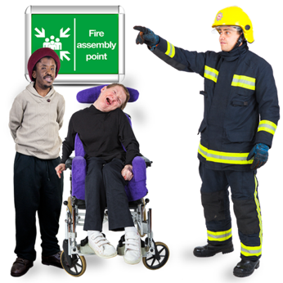

After space weather is over you should follow advice from:
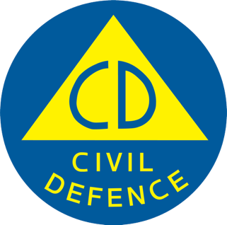
emergency services
civil defence.

You can find information about civil defence near where you are at this website:

https://tinyurl.com/529bteuw

This website is not in Easy Read.

There may be more power cuts after the electricity comes back on.

When there is a power cut the electricity could come back on at any time.
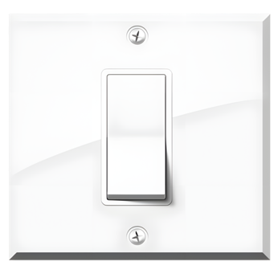

It is a good idea to switch appliances off when you are not using them.

It is important to always be careful around things like:
powerlines
power sockets / plugs.


This information has been written by the National Emergency Management Agency.


It has been translated into Easy Read by the Make it Easy Kia Māmā Mai service of People First New Zealand Ngā Tāngata Tuatahi.

The ideas in this document are not the ideas of People First New Zealand Ngā Tāngata Tuatahi.

All images used in this Easy Read document are subject to copyright rules and cannot be used without permission.


Make it Easy uses images from:


- Photosymbols

- Change Images


- Huriana Kopeke-Te Aho

- SGC Image Works

- T Wood


- Studio Rebeko

- Inga Kramer.

