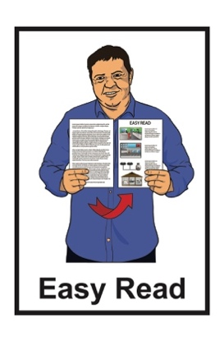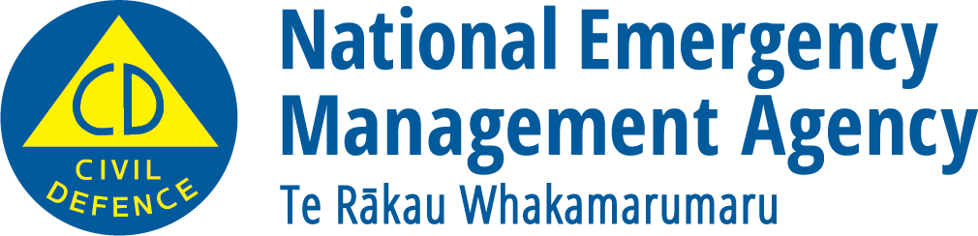

What to do when it is really hot

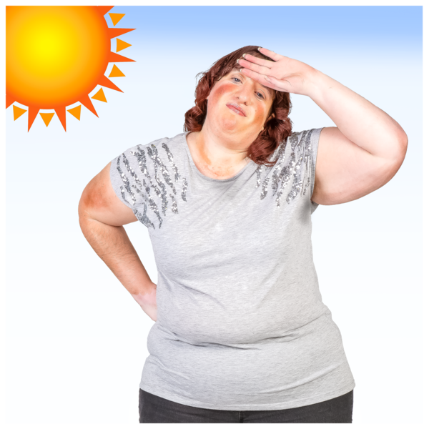

Published: March 2025

# About this document

This is an Easy Read document from the National Emergency Management Agency about how to stay safe when it gets really hot.

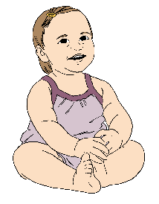

Some people are more likely to feel sick from **heat exposure** like:

babies

older people

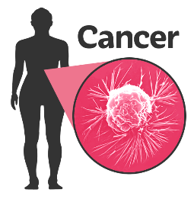

people with long term health conditions like asthma.

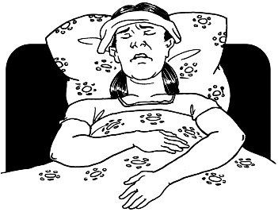**Heat exposure** is when someone gets sick from being in the heat for too long.

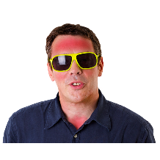Signs of heat exposure are:

a rash

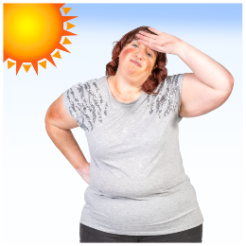heat cramps – when your muscles tighten

sunburn – when your skin becomes red

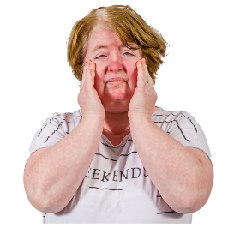heat exhaustion – becoming very tired after being in the heat for too long

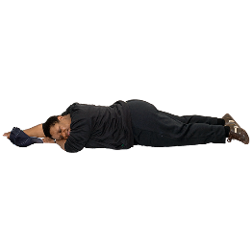heatstroke – fainting from the heat.

You can find information on what to do if you have heat exposure on the  
St John website:

[**shorturl.at/Ze0oG**](https://shorturl.at/Ze0oG)

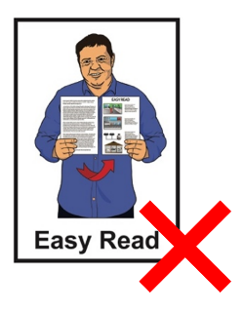

This information is **not** in Easy Read.

On the Health New Zealand website there is information about:

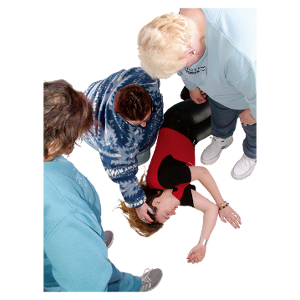how the heat can make someone sick

what to do to help someone who is sick from the heat.



You can find the website here:

[**shorturl.at/dbtta**](https://info.health.nz/keeping-healthy/healthy-homes-environments/health-effects-from-heat)



This information is **not** in Easy Read.

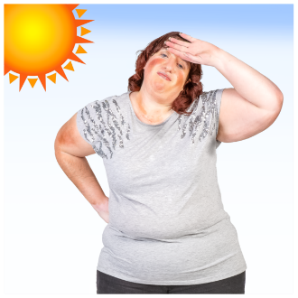When it gets really hot everyone can:

feel the heat

be affected by the **UV radiation** in sunlight.

**UV radiation:**

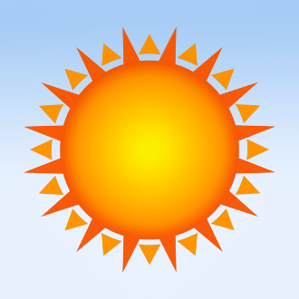comes from the sun

sometimes causes skin cancers

cannot be:

* 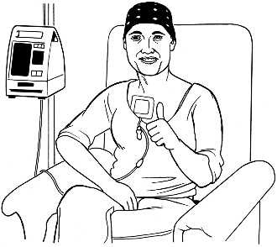seen
* felt.

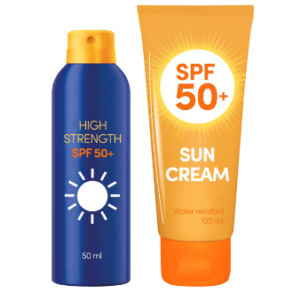The best way to keep yourself safe from UV radiation is to wear:

sunscreen

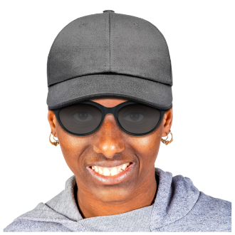sunglasses

a hat

clothes that cover as much of your skin as possible like:

* a thin long sleeved shirt
* long trousers.

More information about UV radiation is available at the Sunsmart website here:

[**shorturl.at/fhA3t**](https://shorturl.at/fhA3t)



This information is **not** in Easy Read.

# Getting your house ready for the heat

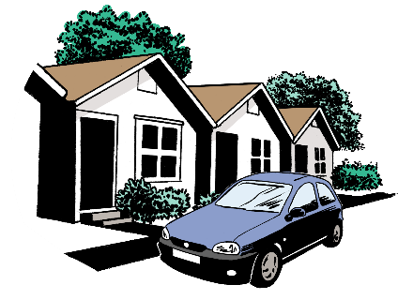

There are lots of ways to get your house ready for hot weather.



On **pages 6 to 9** of this Easy Read document you can find some ways that you can get your house ready.

## Check your insulation

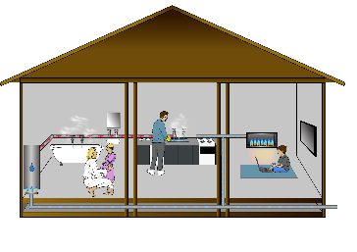

Insulation helps keep your house:

warm in winter

cool in summer.

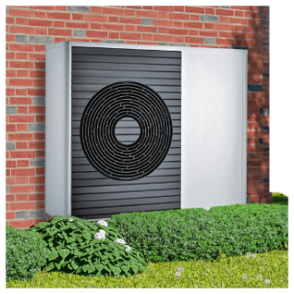

It is also good to check your insulation if you have **air conditioning**.

An **air co****nditioner** blows cold air into whatever room it is in.

Good insulation will keep the cold air from the air conditioner inside your house for longer.

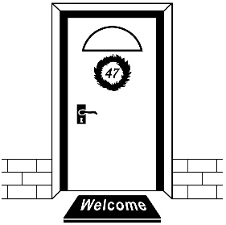

Another way to keep cold air inside your house is to put **weather stripping** on:

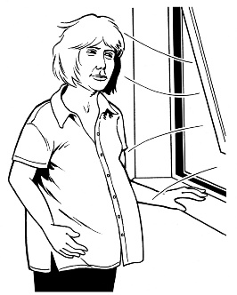doors

windows.



**Weather stripping** is a type of seal that helps keep cold air inside your house.

## Get a fan

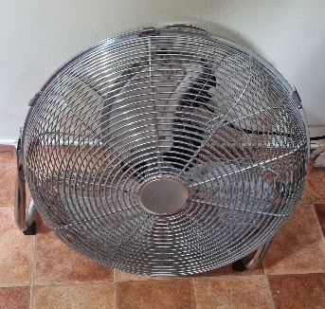

A fan can help keep your house cool.

It is a good idea to put a

fan in the **attic** if you have one.



An **attic** is a room in the roof of a house.

Fans can move warm air out of your attic to keep your house cooler.

## Cover your windows



Another way to keep your house cool is to stop the sun from shining through the windows.

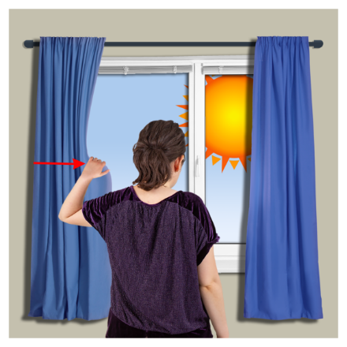

You can do this by:

hanging shades / curtains

adding an **awning** outside your windows.

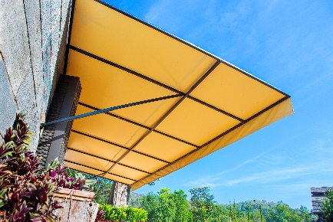An **awning** is a type of shade that you can put on the outside of your house / window to help keep your house cooler.

# How to get yourself ready for the heat

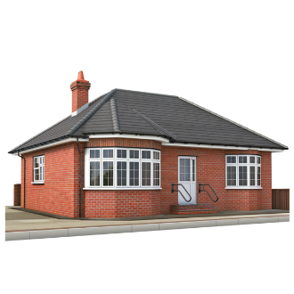Make a plan with your   
whānau / family about staying safe when it gets very hot.

Everyone should know what to do:

* 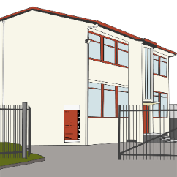 at home
* at work
* 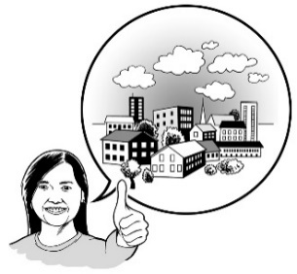at school

in the community.



Some places that do not have air conditioning can be unsafe places to be when it is very hot.

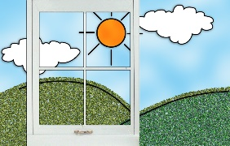Check the weather to make sure it will not be too hot before you make plans for an outdoor activity like going to the park.

You can check the weather on the MetService **website**:

[**www.metservice.com/national**](http://www.metservice.com/national)

MetService also lets you know when the weather is going to get very hot.



This information is **not** in Easy Read.

# What to do when it is hot

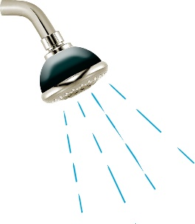A few things you can do to keep cool when it is hot are:

have a cold shower

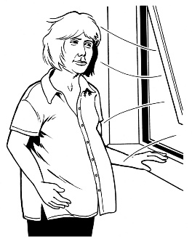wear loose clothes

stay:

* indoors
* in the shade.

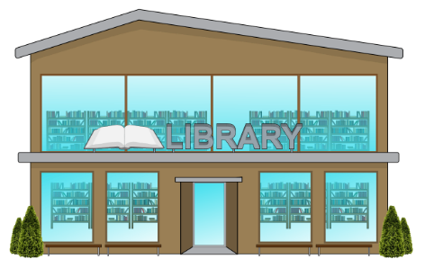If your house becomes too hot go to a public space that has air conditioning like:

a library

the mall.

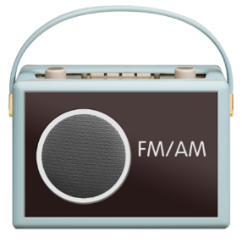To keep yourself updated when it is really hot you can:

listen to the radio

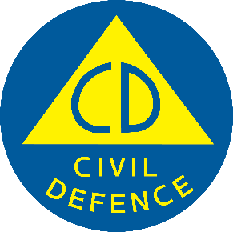follow your **Civil Defence Emergency Management Group** online.



**Civil Defence Emergency Management Groups** are made up of local councils.

You can check who your local Civil Defence Emergency Management Group is on this **website**:

[**shorturl.at/QKL2D**](https://shorturl.at/QKL2D)



This website is **not** in Easy Read.

****Follow the instructions of your local Civil Defence Emergency Management Group.

# Protecting pets / animals

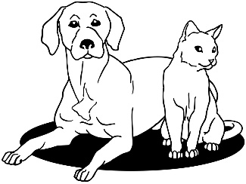

Pets / animals can become very sick when it becomes really hot.

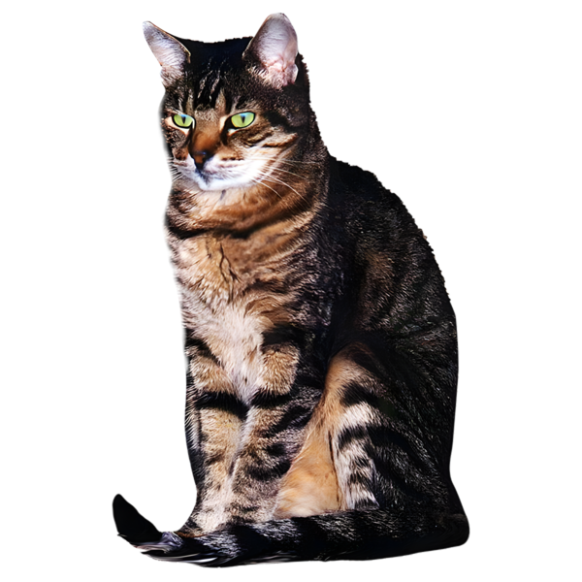

Animals that are more likely to become sick are:

very young animals

old animals

animals with a short snout / nose.

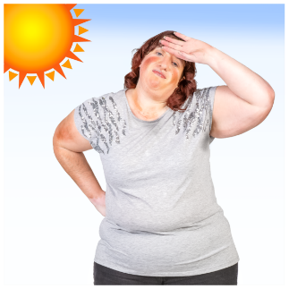Most animals do not sweat.

When they are hot animals will need to:

* pant more – this is when they stick their tongue out

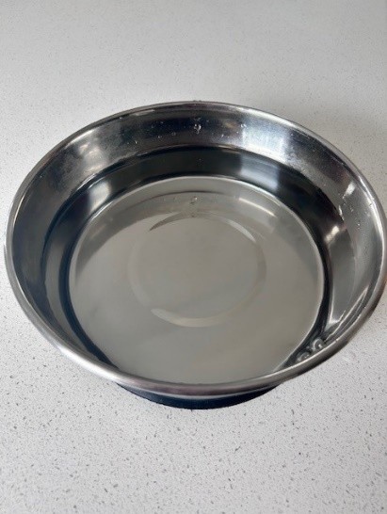have water put on them to help them cool down

be in the shade

drink lots of water.

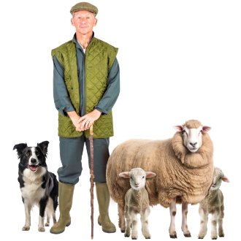

You will need to check on your   
pets / animals more often.

Call your vet if you see signs of heat stress in your pets / animals.

Information about signs of heat stress in animals can be found here:

[**shorturl.at/VPpLL**](https://shorturl.at/VPpLL)



This information is **not** in Easy Read.

This information has been written by the National Emergency Management Agency.

It has been translated into Easy Read by the Make it Easy Kia Māmā Mai service of People First New Zealand Ngā Tāngata Tuatahi.



The ideas in this document are not the ideas of People First New Zealand Ngā Tāngata Tuatahi.



All images used in this Easy Read document are subject to copyright rules and cannot be used without permission.

Make it Easy uses images from:

* Photosymbols
* Change Images
* Huriana Kopeke-Te Aho



* SGC Image Works
* T Wood
* A logo for a school

  Description automatically generatedStudio Rebeko
* Inga Kramer.